Characters

Zombie Ninja

* 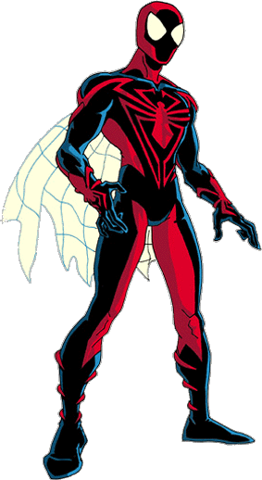Use similar styling to spider man suit
* Add in zombie aspects, flesh, blood, etc.
* Make suit more cloth like
* Loosen suit in areas so that it’s not so tight
* Areas should only have color that are exposed to light or are defining features
* Get rid of the cape
* Add a Katana on his back

Possible sprites

* <http://tsgk.captainn.net/?p=sheetinfo&t=23>
* <http://www.spriters-resource.com/genesis/tmnthyperstoneheist/sheet/6164>
* <http://sdb.drshnaps.com/display.php?object=8646>
* <http://sdb.drshnaps.com/display.php?object=77>

Civilian (checkpoint)

* ?

Savage (mob)

* ?
* <http://www.spriters-resource.com/arcade/denjinmakai/sheet/35466>
* <http://www.spriters-resource.com/arcade/karnovsrevenge/sheet/31020>
* <http://sdb.drshnaps.com/display.php?object=108>

Pyro (mob)

* ?

Hunter (mob)

* Possibly orange hunter jacket
* <http://tsgk.captainn.net/?p=showgame&t=sy&sy=8&ga=258>

Affects

* <http://tsgk.captainn.net/?p=showgame&t=sy&sy=8&ga=330>
* <http://www.spriters-resource.com/snes/tmnt4/sheet/35077>
* <http://sdb.drshnaps.com/display.php?object=182>
* <http://sdb.drshnaps.com/display.php?object=10351>

Molotov

* <http://tsgk.captainn.net/?p=showgame&t=sy&sy=1&ga=2>

Sprite Tutorial

<http://blog.makeyourflashgame.com/81/animated-sprite-with-spritesheet-pushbutton-engine.html>